**oVER-ALL SOLution DOCUMENT for**

**“Exception HANDliNG FRAMEWORK”**

Template version: 0.1

Version: 1.0

Date: 2021-11-27

Status: Draft

Author: TCS FE Development Team

|  |
| --- |
| Confidentiality Statement |
|  |
| This document contains information which is commercially confidential to Tata Consultancy Services Ltd. ("TCS") and is provided for the sole purpose of permitting the recipient to evaluate the proposal submitted within the document. In consideration of the receipt of this document, the recipient agrees to maintain the information it contains in confidence and not to reproduce or otherwise disclose the contents of this document to any person outside the recipient's evaluation team or nominated advisors. The document may not be used, reproduced, or disclosed to others, except as specifically permitted by TCS in writing. The recipient of this document, by its retention and use, agrees to take reasonable endeavours to protect the document and the information it contains from loss or theft.  © 2021 - TATA Consultancy Services Limited (TCS) |

|  |
| --- |
| TATA Code of Conduct |
| All TCS Employees adhere to a Tata Code of Conduct binding on all, available on the Internet at <https://www.tcs.com/tata-code-of-conduct>**.** This includes obligations relating to business ethics, competition, gifts, and donations. We request your support in helping us adhere to the Code in letter and spirit. We request that any violation or potential violation of the code by any person be promptly brought to the notice of the Local Ethics Counsellor or the Principal Ethics Counsellor or the CEO of TCS. All communication received in this regard will be treated and kept as confidential. |

Contents

1. DOCUMENT SCOPE 4

2. Detailed Solution - Overall Architecture & Technology Stack 5

3. EXCEPTION HANDLING process 6

4. GlOSSARY 9

# DOCUMENT SCOPE

The purpose of this document to provide a function and technical overview of exception handling. This document will provide the basic overview of functional journey, functionalities, logical component level understanding of exception handling. It will also provide a guardrail to the low-level design of the application.

# Detailed Solution - Overall Architecture & Technology Stack

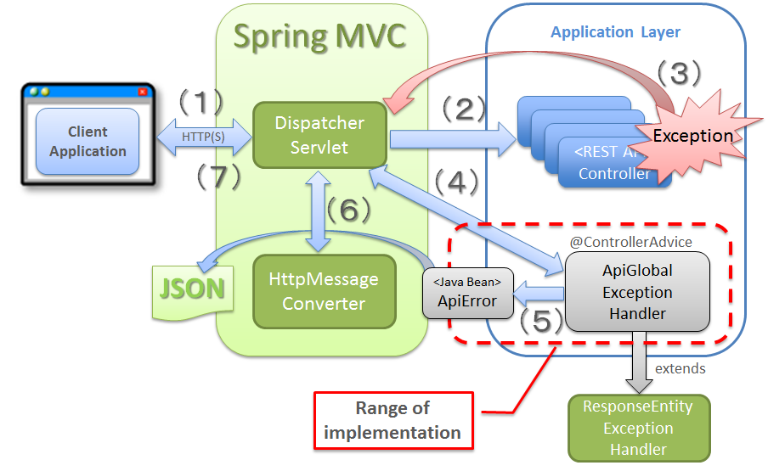

# EXCEPTION HANDLING process

***Defining user-defined Exception:***

***Flow diagram to show how spring will use ASPECT for handling exception:***

***Sequence diagram to show how a service call will return error:***

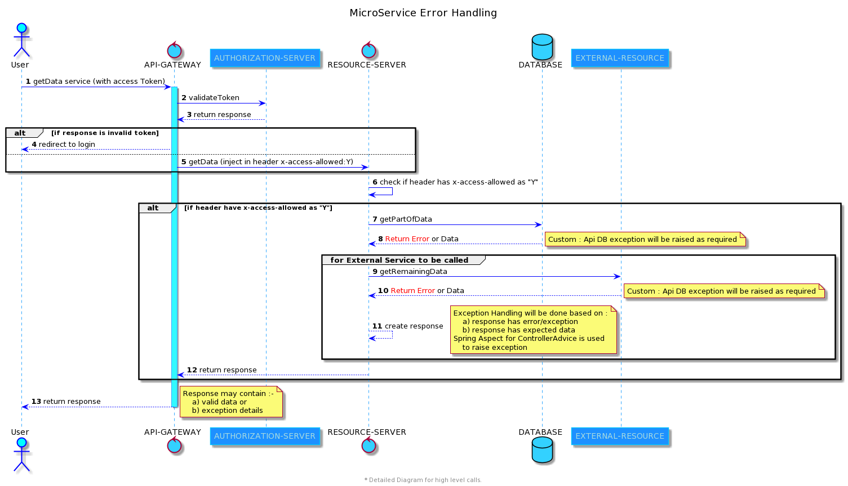

**Sample response from RESOURCE SERVER to GATEWAY for CLIENT or USER :-**

{

"message": "Service Error",  
 "statusCode": "ERR_500",  
 "baseErrorMsg": [  
 {  
 "componentName": "EXTERNAL-RESOURCE",  
 "friendlyMsg": "There is an exception from external service api call",   
 "errorCode": "402",  
 "errorMsg": "Service took too long to respond due to complex calculations"  
 }  
 ],  
 }

**Response in the log file of RESOURCE – SERVER will contain additional error details :-**

{

"message": "Service Error",  
 "statusCode": "ERR_500",  
 "baseErrorMsg": [  
 {  
 "componentName": "EXTERNAL-RESOURCE",  
 "friendlyMsg": "There is an exception from external service api call",   
 "errorCode": "402",  
 "errorMsg": "Service took too long to respond due to complex calculations"  
 }  
 ],  
 "additionalErrorDetails": {  
 "serviceName": "getData",  
 "endPoint": "/domain/getData",  
 "raisedOn": "dd-mm-yyyy hh:mm:ss",  
 "request": "",  
 "response": "402-Service took too long to respond due to complex calculations",  
 "exceptionStackTrace": "",  
 "exceptionType": "ApiServiceException"  
 }  
 }

|  |  |  |  |
| --- | --- | --- | --- |
| # | Parent Node Name | Response Attribute | Description |
| 1 |  | message | Contains short message about the error or exception |
| 2 |  | statusCode | System error code |
| 3 | baseErrorMsg | componentName | Name of microservice or external resource where error has occurred |
| 4 | baseErrorMsg | friendlyMsg | business messages if required to be displayed in UI |
| 5 | baseErrorMsg | errorCode | actual error code from external service api |
| 6 | baseErrorMsg | errorMsg | actual error message from external service api |
| 7 | additionalErrorDetails | serviceName | method name of resource |
| 8 | additionalErrorDetails | endPoint | full service uri with host and port |
| 9 | additionalErrorDetails | raisedOn | time when exception occurred |
| 10 | additionalErrorDetails | request | the request sent to access the resource |
| 11 | additionalErrorDetails | response | the response which came from resource |
| 12 | additionalErrorDetails | exceptionStackTrace | the full exception stack trace if available |
| 13 | additionalErrorDetails | exceptionType | name of the user defined exception raised |

# GlOSSARY

Abbreviations & Terms

The following abbreviations and terms are referred to in this document:

|  |  |
| --- | --- |
| **Abbreviation / Term** | **Description** |
|  |  |
|  |  |

|  |  |
| --- | --- |
| TCS Contact Information | |
| Name | Thomas Bennett |
| Title | Director - Client Relationship AIB |
| Address | TATA Consultancy Services Limited (TCS), Glandore Business Centre, Fitzwilliam Hall, Fitzwilliam Place, Dublin 2, Ireland |
| Business Phone | 086 036 3780 |
| E-mail | [thomas.bennett@tcs.com](mailto:tony.waldron@tcs.com) |

|  |  |
| --- | --- |
| For More Information on TCS | |
| Website | [www.tcs.com](http://www.tcs.com) |

|  |  |
| --- | --- |
| For More Information on Tata Group | |
| Website | [www.tata.com](http://www.tata.com) |

**About Tata Consultancy Services (TCS)**

Tata Consultancy Services is an IT services, consulting and business solutions organization that delivers real results to global business, ensuring a level of certainty no other firm can match. TCS offers a consulting-led, cognitive powered, integrated portfolio of IT and IT-enabled infrastructure, engineering, and assurance services. This is delivered through its unique Location Independent Agile™ delivery model, recognized as the benchmark of excellence in software development. A part of the Tata Group, India’s largest industrial conglomerate, TCS has a global footprint and is listed on the National Stock Exchange and Bombay Stock Exchange in India.

For more information, visit us at [**www.tcs.com**](http://www.tcs.com)

All content / information present here is the exclusive property of Tata Consultancy Services Limited (TCS). The content / information contained here is correct at the time of publishing. No material from here may be copied, modified, reproduced, republished, uploaded, transmitted, posted or distributed in any form without prior written permission from TCS. Unauthorized use of the content / information appearing here may violate copyright, trademark and other applicable laws, and could result in criminal or civil penalties.

**Copyright © 2021 Tata Consultancy Services Limited**